

# Computer science Project

Session: 2024-2025

**A Project Report On “Tic Tac Toe Game”**

Submitted by-Sameer Choudhary

Class – XII (Science A)

Under the Guidance of-

Mrs. Bhavnita Postaria

PGT (Computer Science)

# Contents

|  |  |  |
| --- | --- | --- |
| S.No. | Description | Pg.No. |
| 1. | Certificate | 3 |
| 2. | Acknowledgement | 4 |
| 3. | Introduction | 5 |
| 4. | Python Overview | 6 |
| 5. | Features of Python | 7 |
| 6. | Advantages of Python / How to Install Python | 8 |
| 7. | About MySQL / Installing MySQL | 9 |
| 8. | Advantages of Tic Tac Toe Game / Rules of the Game | 10 |
| 9. | Objective of the Project | 11 |
| 10. | Proposed System | 12 |
| 11. | Source Code | 13 |
| 12. | Introduction of Code | 14 |
| 13. | Main Code | 15 |
| 14. | Results | 14 |
| 15. | Output Screens | 14-16 |
| 16. | Limitations and Future Scope | 26 |
| 17. | Bibliography | 27 |
| 18. | Computer Software & Hardware Requirements | 28 |
| 19. | Thank You!! | 29 |

# Certificate

This is to certify that **Sameer Choudhary** student of class XII (Science) has successfully prepared the report on the Project entitled **“Tic Tac Toe Game”** under the guidance of **Mrs. Bhavnita Postaria** (PGT Computer Science). The report is the result of his efforts & endeavours. The report is found worthy of acceptance as final Project report for the subject Computer Science of class XII (Science).

Signature of Internal Examiner Signature of External Examiner

_________________________ _________________________

Signature of Principal

_________________________

# Acknowledgement

I would like to express a deep sense of thanks and gratitude to my project guide Mrs. Bhavnita Postaria for guiding me immensely through the course of the project. She always evinced keen interest in my project. Her constructive advice & constant motivation have been responsible for the successful completion of this project.

My sincere thank goes to Mrs.Lincy Pancholi (Principal) madam for her coordination in extending every possible support for the completion of this project.

I must thanks to my classmates for their timely help and support for completion of this project.

Last but not the least, I would like to thank all those who had helped directly or indirectly towards the completion of this project.

**Sameer Choudhary**

**Class- XII (Science)**

# Introduction

Tic Tac Toe, also known as Noughts and Crosses, is a classic game that has been around for centuries. It is a simple and yet engaging game that offers countless hours of fun and entertainment. Whether it is played on a piece of paper, a chalkboard, or even on a computer or phone screen, Tic Tac Toe has always been a popular choice among individuals of all ages. The origins of Tic Tac Toe can be traced back to ancient Egypt, where similar games were played on stone tablets. However, the modern version of Tic Tac Toe that we are familiar with today emerged in the 19th century. It quickly gained popularity and has since become a worldwide phenomenon. The rules of Tic Tac Toe are straightforward. The game is played on a 3x3 grid, and the objective is to get three of your symbols in a row - either horizontally, vertically, or diagonally. The symbols used are typically X and O, although other variations may employ different symbols or shapes. Each player takes turns placing their symbol on an empty spot on the grid, and the first player to achieve a winning combination is declared the winner. Despite its simplicity, Tic Tac Toe offers strategic depth and challenges players to think ahead and outsmart their opponents. It may seem like a game of luck at first, but with experience, players can develop strategies and tactics to improve their chances of winning. Furthermore, Tic Tac Toe helps develop critical thinking skills, spatial awareness, and logical reasoning, making it an excellent educational tool for children and adults alike. In addition to its mental benefits, Tic Tac Toe also promotes social interaction and friendly competition. It is a game that can be enjoyed by people of all ages and backgrounds, bringing people together and fostering bonds. Whether it is played during family gatherings, in school classrooms, or even during breaks at work, Tic Tac Toe is a timeless activity that encourages interaction and camaraderie. Over the years, Tic Tac Toe has evolved and adapted to different platforms and technologies. It can now be played in various digital formats, offering new features and options for customization. Online multiplayer options and AI opponents further enhance the gaming experience, allowing players to challenge friends or test their skills against computer-controlled opponents. In conclusion, Tic Tac Toe is a classic game that has stood the test of time. Its simple rules and strategic gameplay make it a favorite among players worldwide. From its humble beginnings to its modern digital adaptations, Tic Tac Toe remains a beloved pastime that brings people together and provides hours of fun and entertainment. Whether you are a seasoned strategist or a casual player, Tic Tac Toe offers something for everyone, making it a game that is here to stay.

# Python Overview

Python is a general-purpose high-level programming language. It is an open source language, released under a GPL-Compatible license. Python Software Foundation (PSF), a non-profit organization, holds the copy-right of python. Guido Van Rossum conceived python in the late 1980s. It was released in 1991 at Centrum Wiskunde & Informatica (CWI) in the Netherlands as a successor to the ABC language. He named this language after a popular comedy show called “Monty Python’s Flying Circus” (and not after python - the snake). In the last few years, its popularity has increased immensely. According to stackoverflow.com’s recent survey, python is in the top ten most popular technologies in 2018. It is also dynamically-typed because it carries out type-checking at run time. It does so to make sure that the type of construct matches what we except it to be. The distinctive feature of python is that it is an interpreted language. The Python IDLE (Integrated Development & Learning Environment) executes instruction one line at a time. The python programming language is one of the richest languages.

**1.Easy:**  Python is a very easy to learn and understand; using this python tutorial, any beginner can understand the basics of python.

1. **Interpreted:** It is interpreted (executed) line by line. This makes it easy to test and debug.

1. **Object** **Oriented:** The python programming language supports classes and objects.

1. **Free and Open-Source:** The language and its source code are available to the public for free; there is no need to buy a costly license.

1. **Portable**: Since it is open source, we can run python on windows, mac, Linux, or any other platforms. Our programs will work without needing to the changed for every machine.

1. **GUI (Graphical User Interface) programming:** We can use it to develop a GUI (Graphical User Interface).

1. **Large Library:** Python provides us with a large standard library. We can use it to implement a variety of functions without needing to reinvent the wheel every time. Just pick the code we need and continue. This lets us to focus on other important tasks.

**Advantages of Python-** **1. Extensible 2. Portable**

## 3. Free & Open-Source 4. Readable 5. Embeddable 6. Improved Productivity 7. Simple and Easy 8. Object Oriented 9. Interpreted 10. Extensive Libraries How to install Python-

1. Point your web browser to the download page on the Python website [(www.python.org)](http://www.python.org/)
2. Select the latest Windows x86 MSI Installer and click on the link to download the .msi installer.
3. Run the installer.
4. Select “Install for all users” and click the Next > button.
5. Keep the default option (C:\Python32\) as the destination directory and click Next > again.
6. Don’t make any changes in the “Customize Python 3.2.3” dialog, just click Next > again.
7. Click Yes if asked if this program should be allowed to install software on your system.
8. Click the Finish button when installation completes.

## About MySQL-

MySql is a fast, easy to use RDBMS (Relational Database Management System) being used for many small and big businesses. MySql is developed, marketed and supported by MySQL AB, which is a Swedish Company.

MySql is becoming is so popular because of many good reasons.

1. MySql is released under an open-source language. So, we have nothing to pay to use it.
2. MySql is a very powerful program in its own right. It handles a large subset of the functionality of the most expensive and powerful database packages.
3. MySql uses a standard form of the well-known SQL data language.
4. MySql works on many operating system and with many languages including PHP, PERL, C, C++, JAVA, etc.
5. MySql works very quickly and works well even with large data sets.
6. MySql is very friendly to PHP, the most appreciated language for web development.
7. MySql supports large databases, up to 50 million rows or more in a table. The default file size limit for a table is 4 GB, but we can increase this (if our operating system can handle) to a theoretical limit of 8 million Tera-Bytes (TB).
8. MySql is customizable. The open-source GPL license allows programmers to modify the MySql software to fit their own specific environments. **For installing MySQL-**

1.For Python 2.7 or lower, install using pip aspip install mysql. connector

2. For Python 3 or higher version, install using pip3 as pip3 install mysql. Connector

**Advantages of “Tic Tac Toe Game”-**

1. Enjoyable methods of learning code.
2. Increase motivation for computer-based programs.
3. Building interest for python language in players.
4. They provide meaningful platform for adaptive learning.
5. Reduce anxiety related to learning and making errors.

1. Encourage spontaneous interest in learning various computer-based languages.

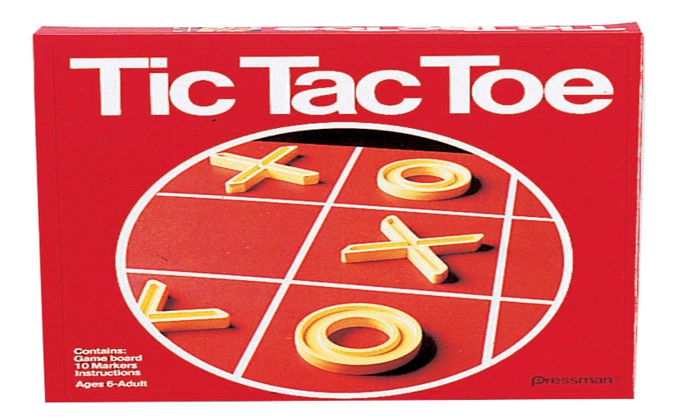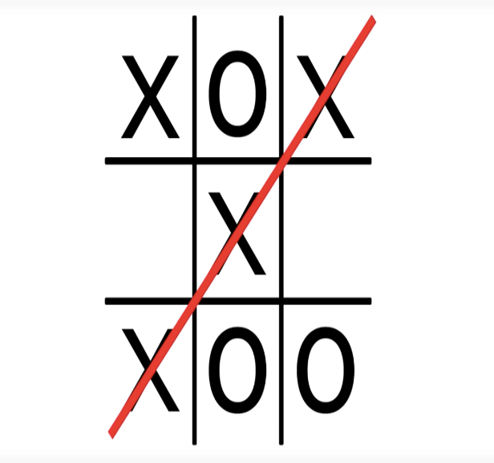

## Rules of the game-

When playing Tic-Tac-Toe, there are several simple and easy-to-follow rules that you should observe. The rules that you need to be aware of include the following:

* The traditional version of Tic-Tac-Toe must be played on a 3×3 grid that incorporates 9 squares.
* Players must select their mark before the game starts (either X or O) and must play the entire game using the same mark.
* Players must take turns, making only 1 mark with each turn.
* Marks can only be placed in empty squares, and once it is placed, it is permanent.
* The winner is the first player to get 3 of their marks in a straight line (the line can be positioned diagonally, vertically, or horizontally).
* The game is over when all 9 squares are filled with marks, even if none of the players have a straight line of 3 marks.
* If neither player has a straight line of 3 marks, it is considered a tie.

**Hope users have fun!!**

# Objective of the project-

The objective of this project is to let the students apply the programming knowledge into a real-world situation/problem and exposed the students how programming skills help in developing a good software.

Some key points are as follows-

1. Utilising modern software tools for programming games.

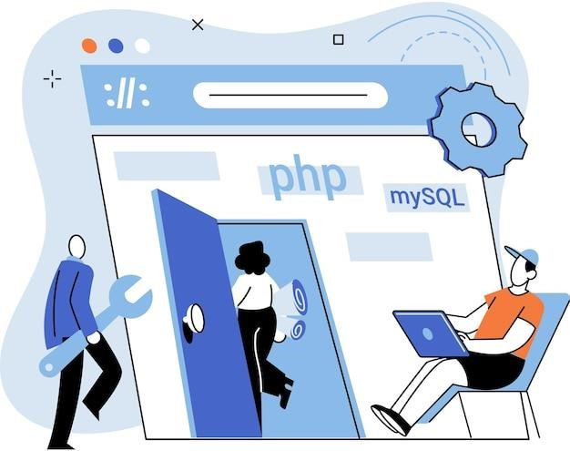

1. Apply object-oriented programming principles effectively when developing small to medium sized projects.

1. Write effective procedural code to solve small to medium sized problems.

1. Demonstrate a breadth of knowledge in computer science, as exemplified in the area of game development.

1. Demonstrate ability to conduct a research or applied computer science project, requiring writing and presentation skills which exemplify scholarly style in computer science.

## Proposed System

The aim of our project is to make a tic tac toe game in python language. This project shows that Python is simple, easy to learn syntax, easy to use and fast to develop.

The python interpreter and the extensive standard library are available in source or binary form without charge for all major platforms, and can be freely distributed.

One has to use the data management software. Many software products working are now in markets, which have helped in making the data easier and efficiently. Now only this software has to be loaded on the computer and work can be done. And MySQL has helped us a lot to make and store data of our game.

And this prevents a lot of time and money. The work becomes very easy with the help of MySQL.

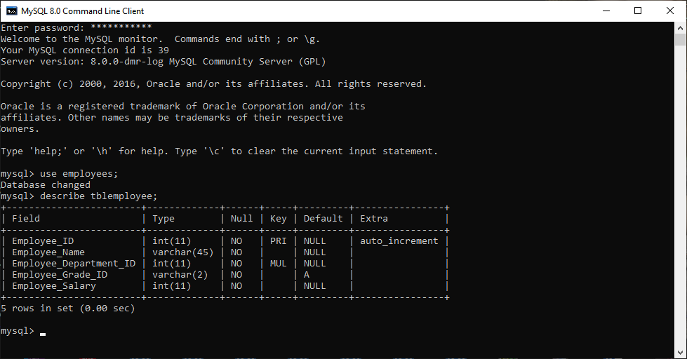

|  |  |  |
| --- | --- | --- |
|  |  |  |
|  |

# SOURCE CODE

l = [['1','2','3'],

['4','5','6'],

['7','8','9']]

def replaceUser(u,sign):

if u == 1 : l[0][0] = sign

elif u == 2 : l[0][1] = sign

elif u == 3 : l[0][2] = sign

elif u == 4 : l[1][0] = sign

elif u == 5 : l[1][1] = sign

elif u == 6 : l[1][2] = sign

elif u == 7 : l[2][0] = sign

elif u == 8 : l[2][1] = sign

elif u == 9 : l[2][2] = sign

def horizontalcheck():

if 'O' == l[0][0] == l[0][1] == l[0][2] or 'O' == l[1][0] == l[1][1] == l[1][2] or 'O' == l[2][0] == l[2][1] == l[2][2] :

return True

elif 'X' == l[0][0] == l[0][1] == l[0][2] or 'X' == l[1][0] == l[1][1] == l[1][2] or 'X' == l[2][0] == l[2][1] == l[2][2] :

return True

def verticlecheck():

if 'O' == l[0][0] == l[1][0] == l[2][0] or 'O' == l[0][1] == l[1][1] == l[2][1] or 'O' == l[0][2] == l[1][2] == l[2][2]:

return True

elif 'X' == l[0][0] == l[1][0] == l[2][0] or 'X' == l[0][1] == l[1][1] == l[2][1] or 'X' == l[0][2] == l[1][2] == l[2][2]:

return True

def diagonalcheck():

if 'O' == l[0][0] == l[1][1] == l[2][2] or 'O' == l[0][2] == l[1][1] == l[2][0]:

return True

elif 'X' == l[0][0] == l[1][1] == l[2][2] or 'X' == l[0][2] == l[1][1] == l[2][0]:

return True

def printMatrix():

print(l[0])

print(l[1])

print(l[2])

def resetdb():

global l

l = [['1','2','3'],

['4','5','6'],

['7','8','9']]

print("User 1 represents O")

print("User 2 represents X")

resetdb()

nl = []

flagu1= True

flagu2 = True

while True:

if len(nl) == 9:

print("Match Tie")

break

if flagu1:

u1 = int(input("User O Chance : enter 1 to 9 : ", ))

if u1 not in nl:

nl.append(u1)

replaceUser(u1,'O')

printMatrix()

flagu2 = True

if horizontalcheck() or verticlecheck() or diagonalcheck() :

print("User 1 wins")

break

else :

print("Position already filled")

flagu2 = False

if len(nl) == 9:

print("Match Tie")

break

if flagu2:

u2 = int(input("User X Chance : enter 1 to 9 : ", ))

if u2 not in nl :

nl.append(u2)

replaceUser(u2,'X')

printMatrix()

flagu1 = True

if horizontalcheck() or verticlecheck() or diagonalcheck() :

print("User 2 wins")

break

else :

print("Position already filled")

flagu1 = False

# Output Screens

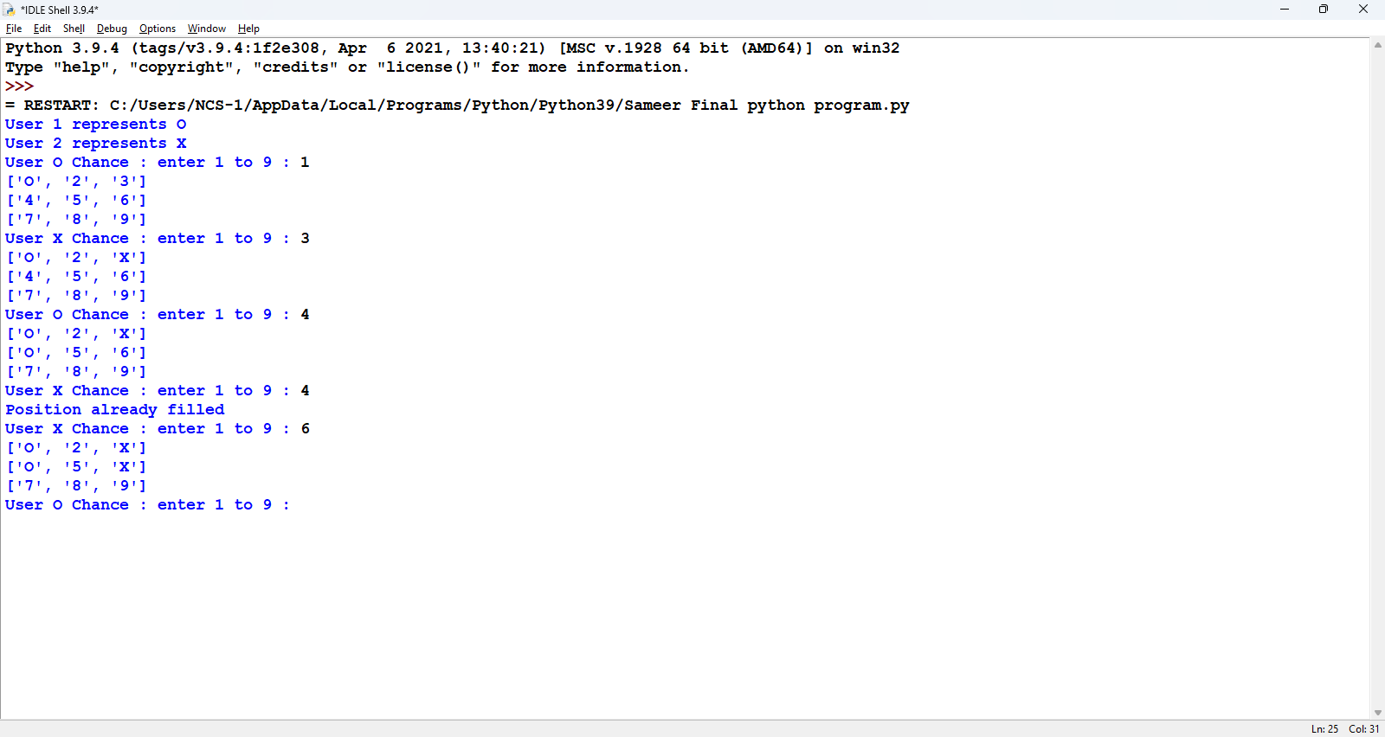

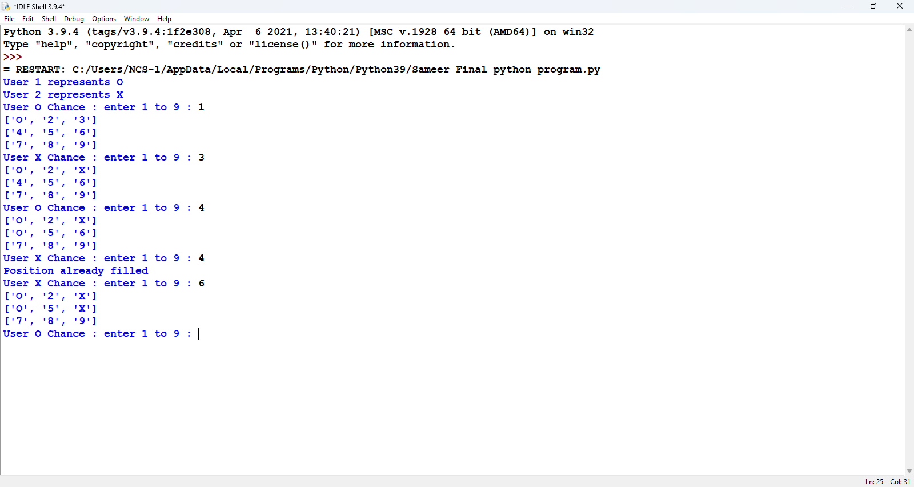

# Scope

## Limitations: -

* Two players can play at a time.
* Registration of players cannot be done.
* Score of players cannot be saved.
* It does not provide timing system.

## Future Scope: -

* Registration of players can be done.
* Score of players can be saved.
* Timing system can be provided.

# Bibliography

1. IDLE Python 3.8.5
2. www.scribd.com
3. cbsepython.in
4. [www.google.com](http://www.google.com/)
5. Computer Science with Python by Sumita Arora Class XIIth(Book)

# Computer Software & Hardware Requirements

## Hardware required: -

Windows 10 or 11

64-bit operating system, x64-based processor

Intel(R) Core (TM) i3-10100 CPU @ 3.60GHz 3.60 GHz)

Printer for printing project

## Software required: -

Windows 11 Pro

MS word, for preparing documentation

Python 3.8.5 (tags/v3.8.5:580fbb0, Jul 20 2020, 15:57:54) [MSC v.1924 64 bit (AMD64)] on win32

*THANK YOU!!*